

English Summer Tasks for 7th graders
משימות קיץ באנגלית לעולים לכיתה ז'
בית ספר נבון, יבנה

ברוכים הבאים לחטיבת ביניים ע"ש יצחק נבון!
עליכם להעתיק 4 מהמשימות הבאות , להשלים אותן, להוסיף תמונות אם צריך, לאגד אותן עם שער מקושט ושם באנגלית ובעברית, ולהגיש אותן למורה לאנגלית בשבוע הראשון של שנת הלימודים.
העבודה והמבדק הראשון שיתקיים יחשבו בציון הראשון בחטיבה

BONUS:
My favourite season is ____________. During __________ I go __________ and I can play ______________. I also like _________, but I don't like
______________________.

my
photo
here
Task 1- All about me
Name: .......................................................... Date: ........ /....... /.......

Hi!
My name is__________. I come from _________. I live in _______________. I am ________ years old. I have a ______________. Her name is ____________, and she is ________ years old.
My favourite food is __________. I also like to eat ____________ and __________, but I don't like _____________ and I never eat ________________.
My favourite drink is ___________. I also like to drink _________ and ___________. I don't like _________.

My favourite TV show is ________________________.
My idol is _________________.
My favourite colors are ___________and ______.
I usually wear ______________
__________________.
I like to play with _______ and __________, but I don't like ___________.
NAME:........................................... DATE: ..............................

TASK 2- A PICTURE OF ME DOING WHAT I LOVE!

- Paste your picture here:

- Complete:

What are you doing
in the picture?

Who is in the picture?


Where are you?
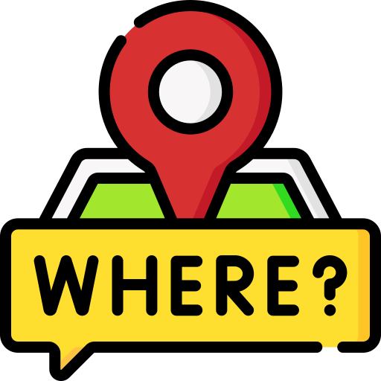
When did you take this
picture?


Task 3- My Best Friend!

Write a profile of your best friend

Name: _______________________________
Age: _________________________________
Gender: _____________________________
Nationality: ________________________
Birthday: ___________________________
Favorite food: _____________________
Favorite colour: ___________________ Draw your best friend!
Hobbies: _________________________________________________________________________________________

What does he/she look like? (hair color, eye color, height…): ______________________________________________________________________________________________________________________________________
What do you do together? What do you like about him/ her?
________________________________________________________________________________________________________________________________________________________________________________________________________________________________________________________________________________________________________________________________________________________________________________________________________________________________________________________________________________________________________________________________________________________________________________________________________________________________________________________________________________________________________________________________________________________________________________________________________________________________

Task 4-
1*Match the pictures with the hobbies’ names
כתוב כותרת HOBBIES בראש הדף, העתק את התחביבים באנגלית, תרגם לעברית, וכתוב מה התחביבים שלך
Task 4- Hobbies


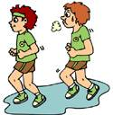
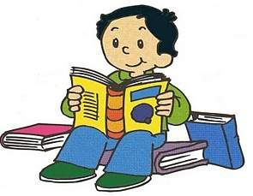

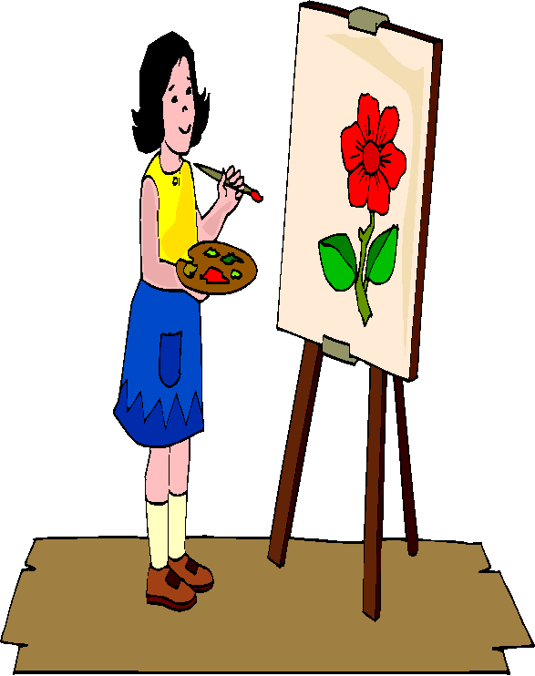

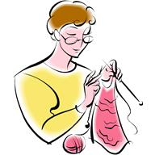

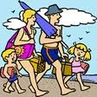
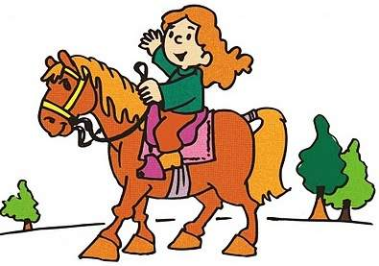
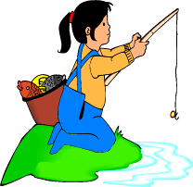
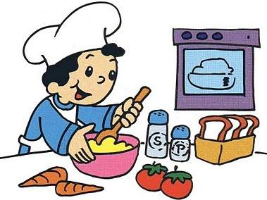

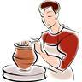
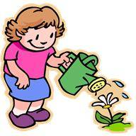
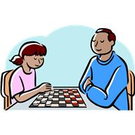
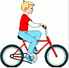
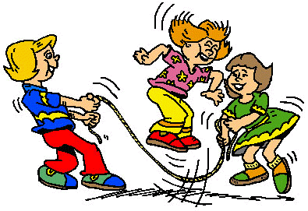

19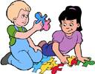


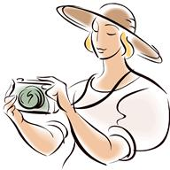
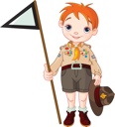
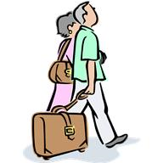
4
3
2
1

- Watching TV. …….
- Playing chess. …….
- Riding horses. …….
- Shopping. …….
- Dancing. …….
- Watering flowers. …….
- Travelling. …….
- Cooking. …….
- Riding bicycles. …….
- Singing. …….
- Playing guitar. …….
- Knitting. …….
- Going to the beach. …….
- Drawing. …….
- Reading books. …….
- Fishing. …….
- Jogging. …….
- Taking photos. …….
- Pottery. …….
- Puzzle. …….
- Scouting. …….
- Skateboarding. …….
- skip a rope……..
- Hunting. …….

8
7
6
5

12
11
10
9

16
15
14
13

20
18
17

24
23
22
21

2*Now, tell us about your hobby.
…………………………………………………………………………………………………………………………………………………………………………………………………………………………………………………………………………………………………………………………………………………………………………………………………………………………………………………………

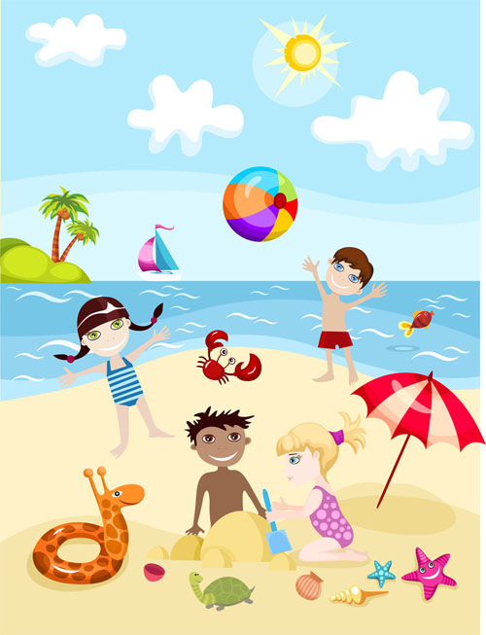
TASK 5 A day at the beach
Write True or False for each statement.
- It is a sunny day……………………………..
- There are five people on the beach ……………………………………..
- There are two ships…………………………………
- There is a crab ……………………………………..
- The children are playing with a ball …………………………………..
- There are two fish swimming …………………………………….
- There are sea shells on the beach ………………………………………
- The family looks happy ………………………………………..

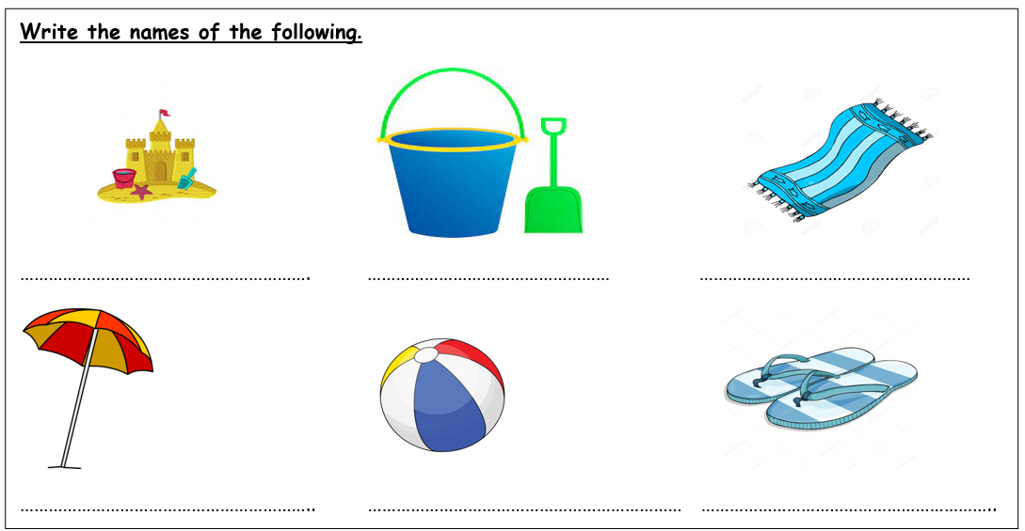

Task 6- The Days Trains- רכבות הימים
העתק את שבעת הרצפים והשלם את שמות הימים החסרים
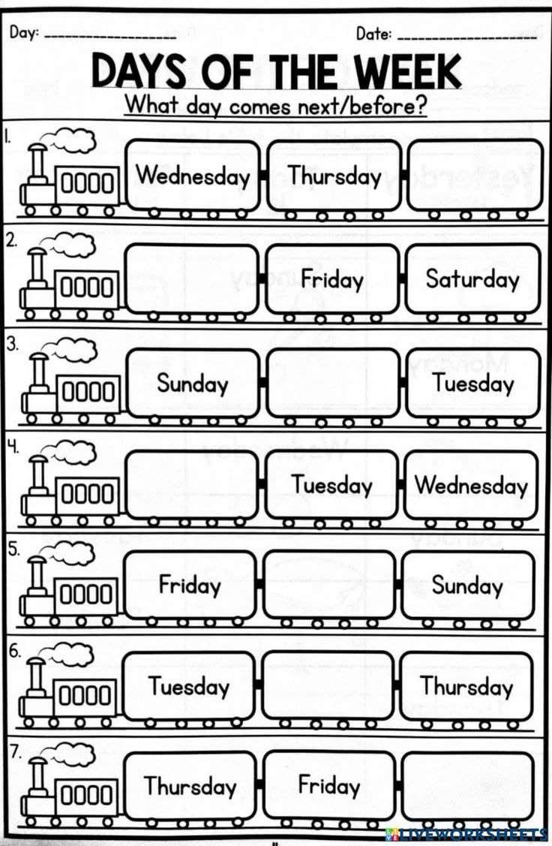
Task 7- A day at the lake
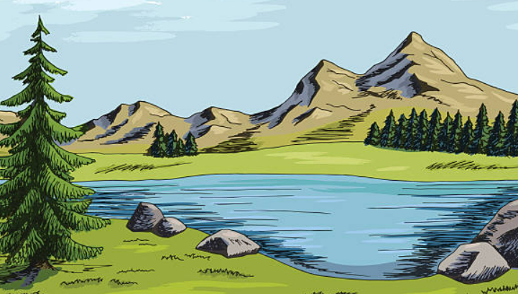
Last week I spent a wonderful day at the lake that is not far from the place I live. I went there with my parents, my sister Helen and my cousins Anthony and Mike. We went on Sunday morning. I was so excited that I woke up at 7 o’clock even though we would leave at 10! I had breakfast, then a quick shower and soon later I prepared my rucksack. When Helen got up, at about 9, she was astonished because she couldn’t believe I had already packed my things.
My mum got up early too. She prepared some sandwiches, some chocolate cake and some fruit juice to drink, in fact we had a picnic at the lake. It was sunny and warm, and we had a very good time there. After lunch we started telling jokes… it was amazing! I hope we will go to the lake again as soon as possible!
Emma

TRUE OR FALSE?
1 Emma has got two brothers. T/F 6 Helen got up at 10 last Sunday. T/F
2 Emma had a picnic with her friends. T/F 7 Emma brought a rucksack with her. T/F
3 Emma went to the lake last month. T/F 8 They had lunch at the lake. T/F
4 Last Sunday Emma woke up very late. T/F 9 They drank some fruit juice. T/F
5 Helen is Emma’s sister. T/F 10 It was sunny and windy. T/F

ANSWER THE QUESTIONS.
1 Where did Emma go last Sunday? 6 When did they go to the lake ?
--------------------------------------------------- -----------------------------------------
2 Who did she go with? ------------------ ---------------------------------------------
--------------------------------------------------- 7 What did Emma’s mum prepare for lunch?
3 What time did Emma wake up? ---------------------------------------------------
--------------------------------------------------- 8 What was the weather like?
4 What time did Emma and her family leave? ---------------------------------------------------
--------------------------------------------------- 9 What did they do after lunch?
5 What time did Helen get up? ----------------------------------------------
---------------------------------------------------
10 Do you like having picnics? Write a letter to your friend about a picnic you had.
----------------------------------------------------------------------------------------------------
----------------------------------------------------------------------------------------------------
----------------------------------------------------------------------------------------------------
----------------------------------------------------------------------------------------------------

